Alex Brough

once upon a time in an evan far far away there lived euan a small mythical creature who didn’t have many friends but he was in love with euan showers , they lived and died the end
TUTORING SHI-

Contents
No table of contents entries found.

Business context

The company I will be developing the product for is GIbJohn Tutoring.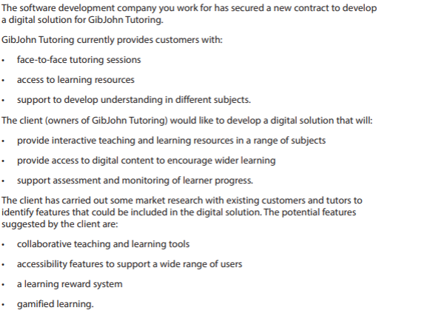

Functional Requirements
Home page – the website will need a home page to introduce the user to the website and provide information and links to other pages.
Navigation bar – the website will need a navigation bar to allow the user to effectively navigate around the pages of the website for a good user experience.
Footer – a footer will be needed to allow the user to know when they have reached the bottom of the page and will contain links which would allow the user to navigate effectively to all pages of the website.
Policy page – there will need to be a page which would allow the user to view policies and legal information so the website is well aligned with the law.
Accepting policies and cookies functionality – there will need to be functionality to allow the users to reject or accept cookies or the website's policies.

Admin page – there will be a page where the admins can change values and deal with users account problems.

Face to Face Tutoring Sessions
- there will need to be a page for booking tutoring sessions
- there will need to be form options for booking tutoring sessions
- there will need to be account functionality so bookings can be tied to accounts
- users should be able to cancel their tutoring sessions

Access to Learning Resources
- there will need to be a page for accessing learning resources such as articles and informational video clips
- there will need to be a way for the user to log in so they can then access these resources
- there will need to be ways to upload additional learning resources to the system

Support to Develop Understanding in Different Subjects
- there will be a page which will allow the user to contact support to get help for all the subjects provided
- there will be a form which would allow tickets to be sent to support workers to answer

Provide Interactive Teaching and Learning to Encourage Wider Learning
- there will be interactive quizzes which would allow the users to test their knowledge and improve upon their weak areas
- there will be games to play which would be progressed by getting the answers correctly

Support Assessment and Monitoring of Learner Progress
- The quiz results will be recorded to provide insights into the learner’s progress. Monitoring the results will allow trends in the user’s progress to be identified
- there will need to be a system which would allow the admins to view users' progress

Non-Functional Requirements

Collaborative Teaching and Learning Tools
- there could be a video chat feature which would connect a class to the teacher which would allow the whole class to collaborate remotely

Accessibility Features to Support a Wide Range of Users
- screen reader compatibility
- high contrast mode
- keyboard navigation
- simple and clear language
- consistent page layouts
- subtitles or captions for videos
- transcripts for audio content
- clear instructions and error messages
- ability to review or correct form entries

Learning Reward System
- a learning reward system could be implemented through awarding points or badges when users complete quizzes, activities, or learning resources
- the reward system could motivate learners to continue engaging with the learning materials and track their achievements

Gamified Learning
- gamified learning could be implemented through points, levels, or leader boards to encourage engagement
- users could unlock new content or achievements by successfully completing learning activities or quizzes
Performance
- The website pages should load quickly to provide a seamless user experience.
- The images contained should be in a WEPG format to allow for quick loading.
Security
- The website should protect against account breaches by creating a secure login system.
- The register form should make it so the user’s password has to be a certain strength to be valid.
Compatibility/Responsiveness
- The website should be tested across all common browsers to ensure that it is compatible and will work for a wide range of users.
- The website should work on all devices and screen sized such as mobile, tablet, smart watch and desktop.
Legal
- the website should follow the privacy policy laws ensuring no legal noncompliance occurs
- The website should follow the GDPR laws ensuring no breaches or noncompliance occurs.

Empathy maps

Empathy Map – Student / Learner
Says
- “I need help understanding this topic.”
- “I want to improve my grades.”
- “The quiz helped me see what I don’t understand.”

Thinks
- Wants learning to be simple and engaging
- Wonders if the resources will actually help them improve
- Thinks interactive activities and games would make learning easier

Does
- Logs in to access learning resources
- Completes quizzes and learning games
- Books tutoring sessions when extra help is needed
- Watches videos and reads learning materials

Feels
- Motivated when progress improves
- Frustrated when they don’t understand topics
- More confident when they receive help or feedback
- Encouraged by rewards or progress tracking

Empathy Map – Parent / Guardian
- Says
- “I want my child to succeed in school.”
- “I need a reliable tutoring service.”
- “I want to track my child’s progress.”

Thinks
- Wonders if the tutoring service is worth the money
- Wants the platform to be safe and easy to use
- Thinks progress tracking will help monitor improvement

Does
- Books tutoring sessions
- Checks learning progress or quiz results
- Helps their child access learning resources

Feels
- Reassured when they see their child improving
- Concerned if progress is slow
- Confident when tutors provide clear support

Empathy Map – Tutor
Says
- “Students need different ways to understand topics.”
- “I want to monitor student progress.”

Thinks
- Interactive tools will improve student engagement
- Progress tracking will help identify weak areas

Does
- Uploads learning resources
- Reviews quiz results and progress
- Provides support and answers questions

Feels
- Satisfied when students improve
- Responsible for helping students succeed
- Motivated when tools make teaching easier

Empathy Map – Admin
Says
- “I want to cancel a user’s booking.”
- “I want to edit some pricing on the website.”

Thinks
- This system is easy to use
- These fields are well labelled

Does
- Changes the pricing on the admin dashboard
- Cancels users’ bookings
- Deletes users’ accounts

Feels
- Happy when the system works smoothly
- Content when the work is completed easily
- Stressed when the system errors and they cannot refund a booking

User stories

Acceptance criteria

KPI

